**ARTICLE TITLE**

**(GARAMOND 12PT, ALL IN CAPITALS AND BOLD)**

**Abstract (Abstract title must be aligned to the left edge, Garamond 10pt, bold)**

English articles should have title and abstract written in English at the beginning. Abstract text should be at most 200 words, written with Garamond 10pt, aligned to both edges and fit in one page. In abstracts, research problem/aim, method, findings and conclusions should be mentioned. There shouldn’t be any quotations and citations.

**Keywords:** At least 3 up to 5 words or word groups, Garamond 10pt, each word starting with capital letter and seperated with comas.

**Introduction (Except for the Main Headings of the Article, the First Letters of the Other Headings Should be Capitalized and the Other Letters Should be Lowercase. Unnumbered, Aligned to Left, Garamond 12pt, Bold)**

Introduction section should start at the second page. Introduction heading should not be numbered. Body text of the article should be written with Garamond 12pt and aligned to both edges. Space before and after paragraphs should be 6 nk. Paragraphs, including headings, should not be indented throughout the article. The page structure should be prepared with 2.5 cm from the top and bottom, 2 cm from the right and left, and a gutter margin of 0.5 cm from the left. Article should be at most 20 pages with tables and figures.

If heading classification is to be made in the text (left to the author’s preference), the classification should be done with numbers: 1, 1.1., 1.1.1., 2., 2.1., 2.1.1., 3., 3.1.

Paragraph indentation should not be used with headings, and the first letter should be capitalized, other letters should be lowercase, left-aligned, Garamond 12pt, bold.

**Method**

In order for your research to fall into the context of a “Research Article”, it must have a method related to Research Methods in Social Sciences. In studies requiring ethics committee approval, information about the permission (name of the committee from which the permission was obtained, date and number) should be included in the method section (For example: Before starting the research, permission was obtained from the XXXXXXXXX University Social and Human Sciences Publication Ethics Committee (Decision number: 2025/31) and the XXXXXXXXX University Rectorate.).

**Tables, Figures and Images**

Each table, figure and/or image used in the article must have a title and a title number.

Table, figure and/or image titles should be placed under the tables, figures and/or images, and should be written with 12pt Garamond font, aligned to the center. Table, figure and/or image titles should be numbered and numbers should be bold (such as “**Table 1.**”- “**Figure 5.**” - “**Image 7**.”). Table, figure and/or image titles should be written in italics. All tables, figures and/or images should be aligned to the center.

When preparing tables, inner vertical lines and right and left borders should be removed. Table content should be written in 10pt Garamond font. Tables should fit on a single page. They should not be divided by sliding to another page.

|  |  |  |
| --- | --- | --- |
| Sabit Etkiler Tahmincisi | | |
| Testler | **İstatistik değeri** | **Olasılık değeri** |
| Friedman |  |  |
| Frees |  |  |
| Pesaran CD |  |  |
| Rassal Etkiler Tahmincisi | | |
| Testler |  |  |
| Friedman |  |  |
| Frees |  |  |
| Pesaran CD |  |  |
| Frees Q Dağılımı Kritik Değerleri | | |

**Table 1:** *Friedman, Frees, Pesaran Yatay Kesit Bağımlılığı Test Sonuçları*

*Note: %1 önem düzeyinde istatistiksel olarak anlamlılık * işareti ile gösterilmiştir.*

*(Must be written with Garamond 10pt in italics.)*

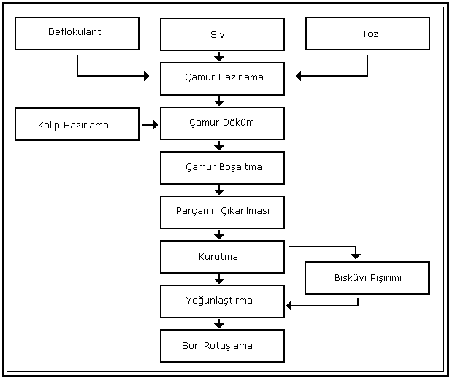

Figure 5.7. *Döküm çamurunun hazırlanmasında takip edilen aşamalar*.

Resource: (Akca, 2009, s. 65)

(The resource specified under the figures should be written in Garamond 10pt font.)

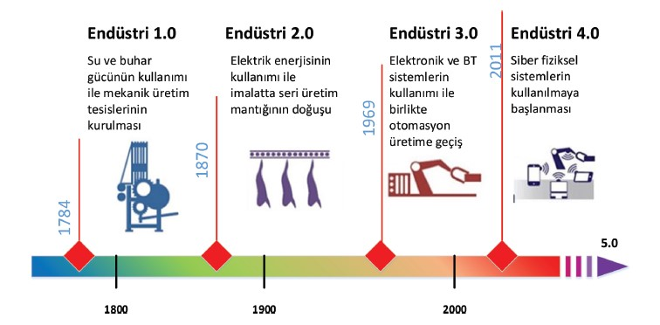

**Image 1:** *Endüstri 4.0*

**Resource:** <https://www.mediaclick.com.tr/tr/blog/endustri-4-0-nedir>, Erişim tarihi: 16.01.2021

(The resource specified under the images should be written in Garamond 10pt font.)

**Conclusion**

The findings regarding the results of the research are written. In addition, any suggestions regarding the subject can be included in this section.

**Funding (If Any)**

This work was supported by the Name of the Institution [Project no: XXXXX].

**Acknowledgement (If Any)**

**Author Contribution (Required for articles with multiple authors)**

**References (Unnumbered, Left-aligned, Garamond 12pt, Bold.)**

Examples:

Sağlam, Y., Egeli̇, H. A. ve Egeli̇, P. (2017). Gelişmiş ve gelişmekte olan ülkelerde Ar&Ge harcamaları ve ekonomik büyüme arasındaki ilişki: Panel veri analizi. *Sosyoekonomi*, *25*(31), 149-166.

Soete, L. G. & Wyatt, S. M. (1983). The use of foreign patenting as an internationally comparable science and technology output indicator. *Scientometrics*, *5*(1), 31-54.

* The reference title should be given immediately after the conclusion. It should not be given on a separate page.
* All references should be prepared using Garamond 12pt, single line spacing, and 6nk before and after paragraph spacing.
* Each work entry in the references **must be spaced 1.25 cm apart.**
* References text must be aligned to both edges.
* The references section should be prepared in accordance with the Mentor, Academic Art and Design Journal Article Writing Guide.
* In the references section of English articles, when citing works with two and/or more authors, “&” symbol should be used instead of “ve/and”.
* If you have used archive documents in your study, these documents should be given under a separate subheading (Archive documents) in the bibliography.